Task 4

Lab4: Hata Okumura Model

Name: abdelrahman matarawy Sayed

section: 5

* **Objectives:**
  + Understand Hata Okumura model.
  + effects of diffraction, reflection and scattering of transmitted signals on the received power.
  + To simulate the path loss in three different types of environments using MATLAB.
* **The received power level in dBm is given by**:
  + $ρ_{r}$ (dBm) = $pt$ (dBm) + Gt(dBi) − Gr(dB)
* **The generic form expression for path loss (PL) in dB:**
$ρ_{L}(dB) = A + B log10(d) + C$

* **The factors A,B depend on the frequency of transmission, antenna heights and the type of environment:**
  + A = 69.55 + 26.16log10(fc) − 13.82log10(hb) - a(hm)
  + B = 44.9 − 6.55log10(hb)
* Task Requirements:
  + a) plot a graph for the path loss vs. distance using Hata model, for fc = 1500 MHz, hb = 70 m and hm =1.5 m in following environments:

1. Open

2. Suburban

3. Metropolitan

* Function Code:

* Main Code:

* OutPut:

* b) For each of the plotted cases find the maximum range that can be covered by a station radiating a power of 1KW given that the receiver sensitivity is -100dBm.

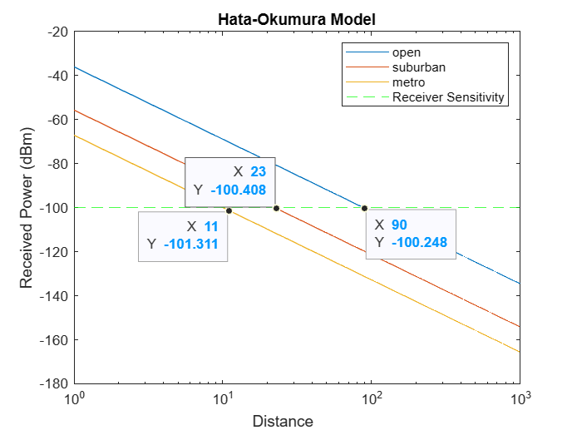

1. open = 11 km
2. suburban = 23 km
3. metropolitan = 90 km

c) Plot the graphs in point (a) at different values of hb (70m-100m-130m-160m) to show the effect of changing the base station height on the path loss.

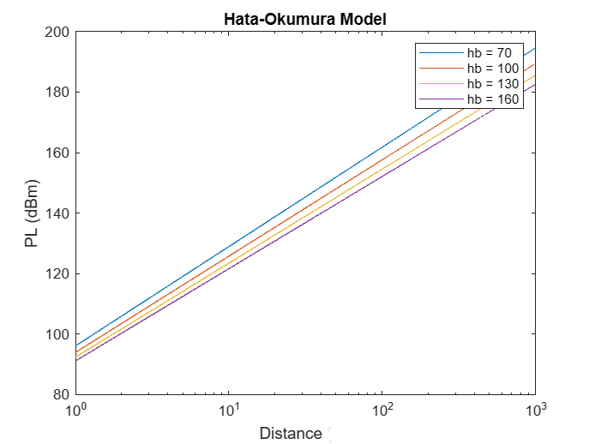

* 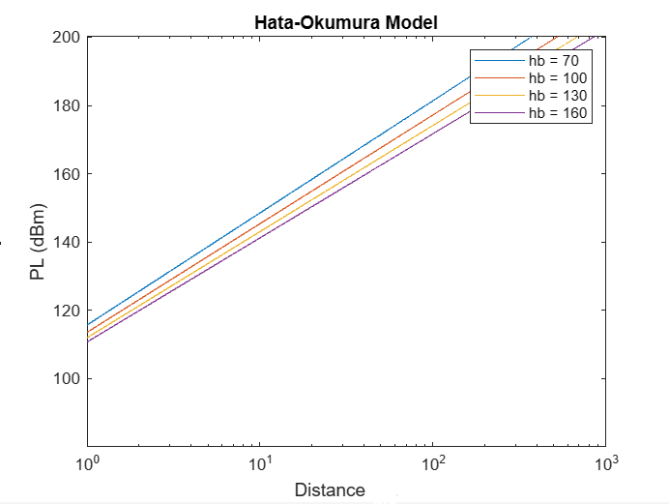Open:

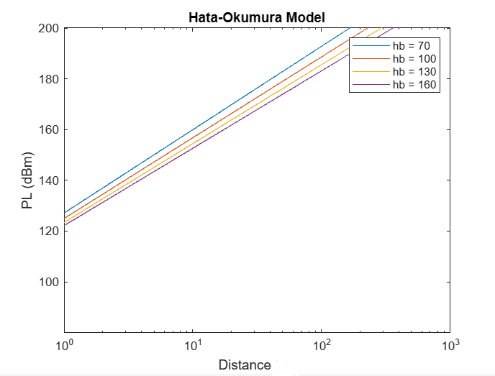

* Suburban:
* metropolitan: